# Text classification

Text classification tags any snippet of text based on the historical data you provide. This allows you to streamline your business by automatically tagging new text.

In this lab, we will build and train a text classification model. We will then use the Predict action to analyze text and then take action based on the results.

**Note:** If you are building the first model in an environment, click on Explore Templates to get started.

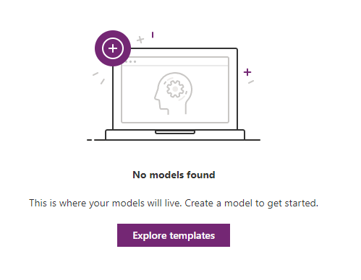

# Exercise 1 – Build the text classification model

1. From the left navigation, expand AI Builder and select Build. Select Text Classification.

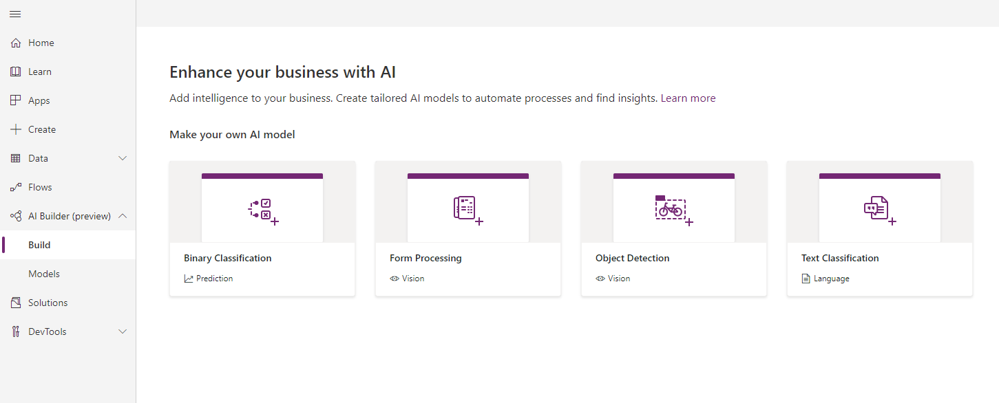

1. Name your model. Because you are working in a shared environment make sure to include your name as part of the model name. This will make it easier to find later. Click Create.

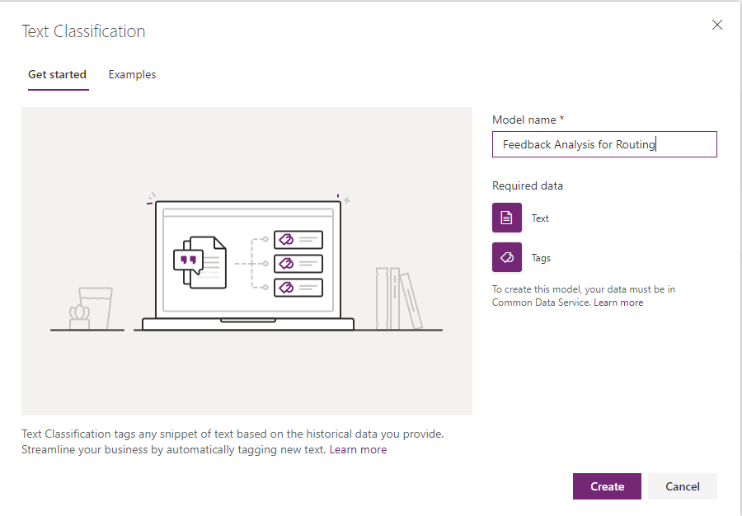

1. Your screen should look like the following image. Click Select text.

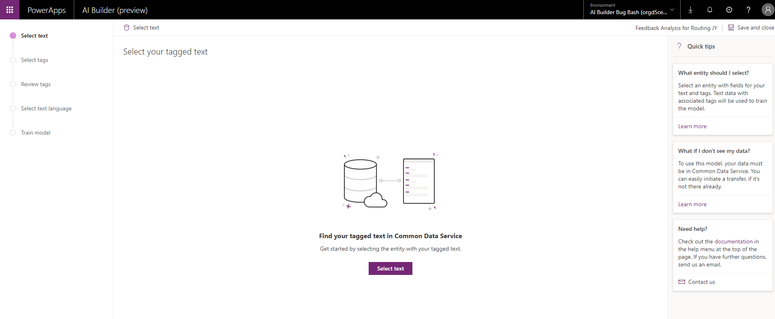

1. Choose healthcare_feedback for the entity.

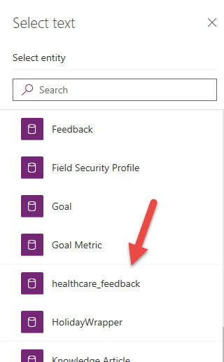  
  
  
5. Select Text for the field. Click Select field. This identifies the data that will be analyzed.

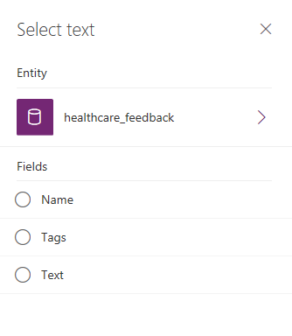

1. Review a preview of the data that will be classified. Click next.

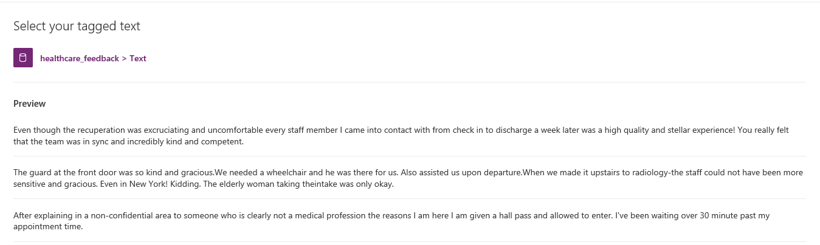

1. Now we will select tags. Click Select Tags.

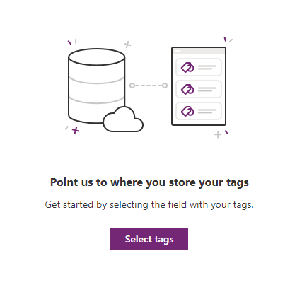

1. Select Tags.

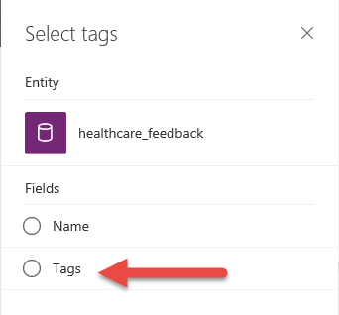

1. Select Comma as the separator. Click Next.

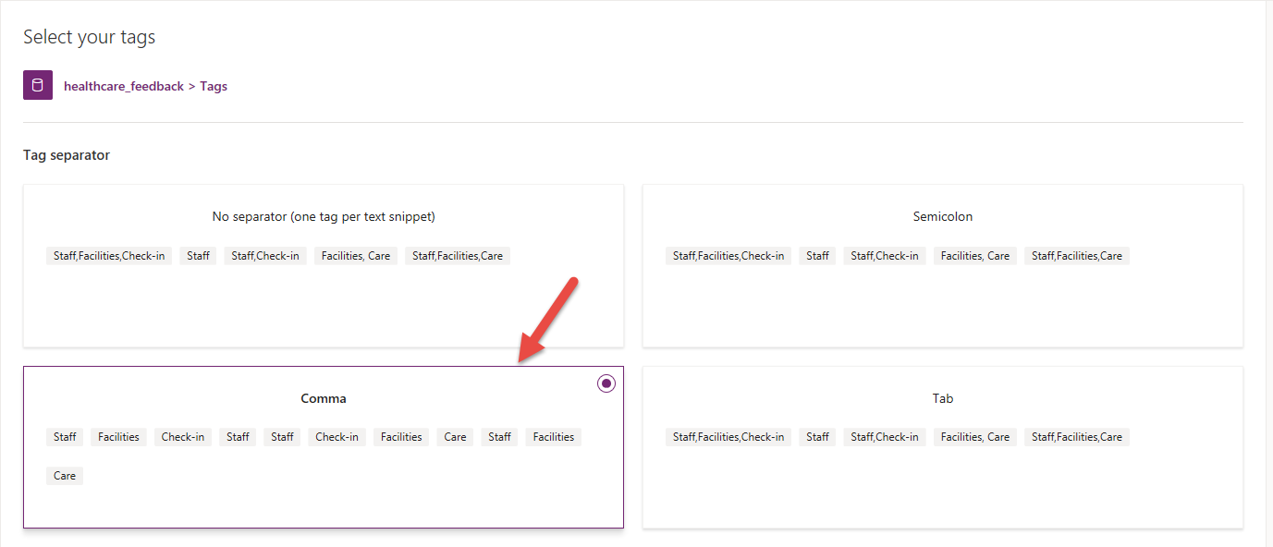

1. Review the text and tags. Click next.

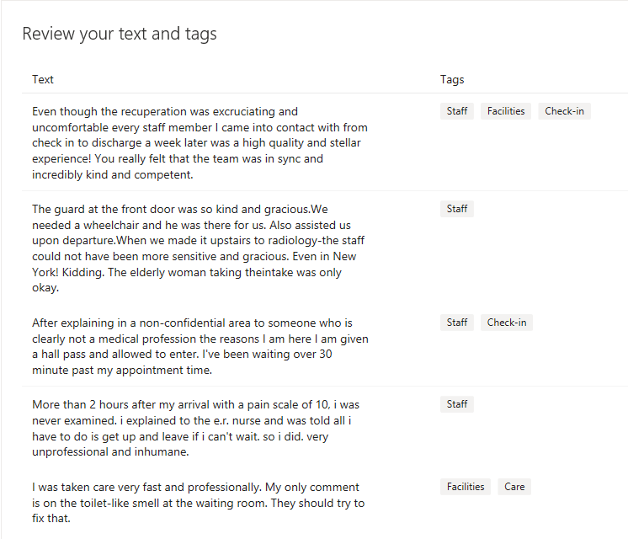

1. Select English and click Next.

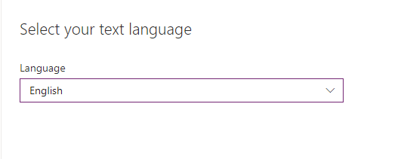

1. Confirm the configuration and select Train.

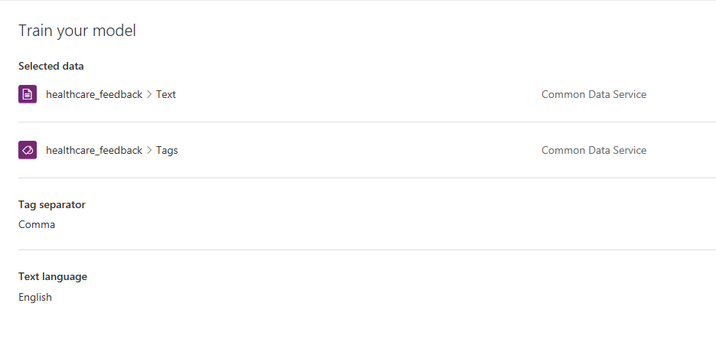

1. Locate and open your model. If you need help finding it, type your name into the search box.

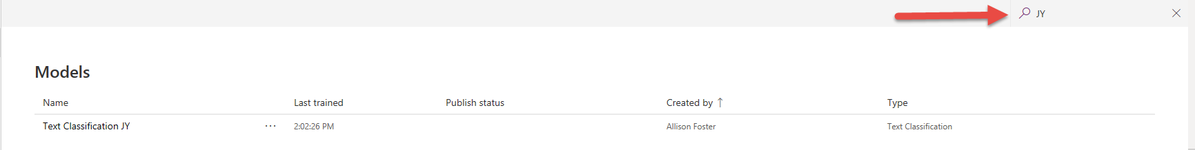

1. Review the performance of the model. Select Quick test.

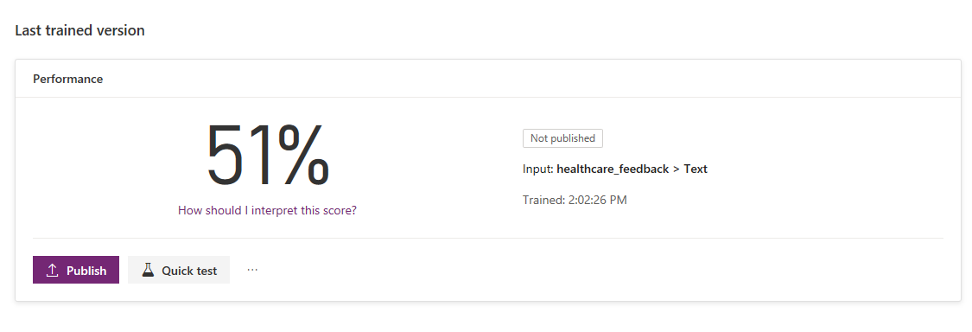

1. Here we can test and validate our model. Add the following text to classify: The doctors and nurses took care of me well during my stay.

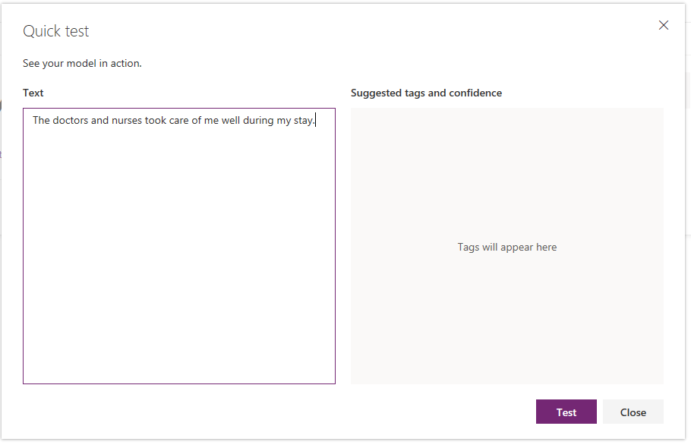

1. Click Test and review the classification. Close the test dialog. 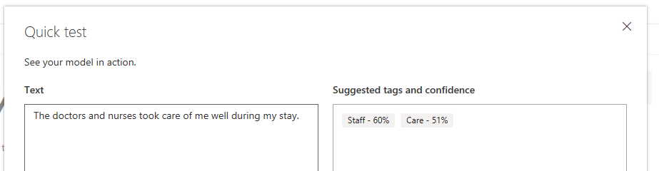
2. Now you can test any text. Test the following: The weather in Atlanta is great!   
     
   Close the test dialog.

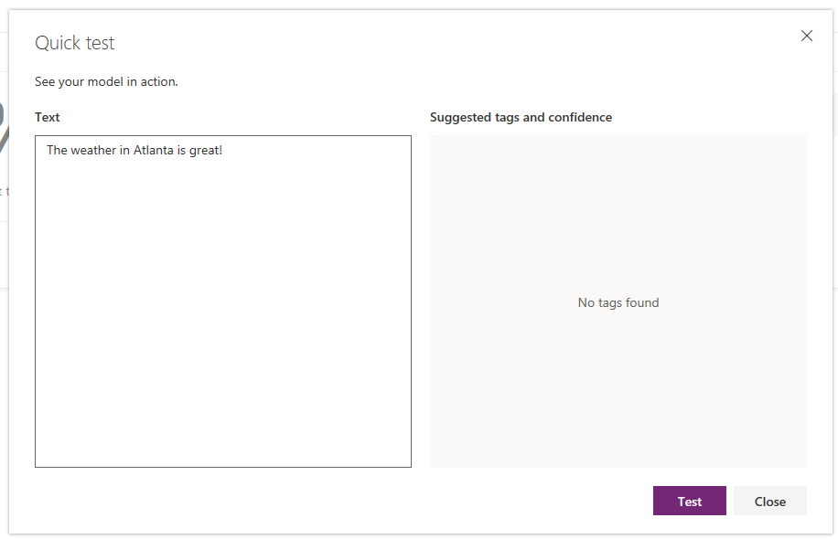

1. Publish your model.  
     
   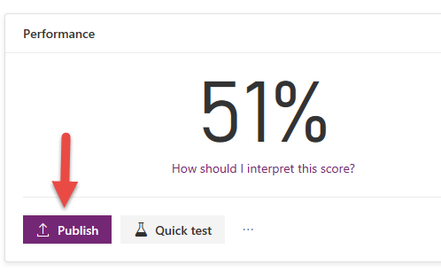

# Exercise 2- Use the model from Microsoft Flow

Once the model has been trained you can use the model from Microsoft Flow. This allows you to leverage text classification in the automation you build. In this exercise, we will focus on how to use the Predict action to analyze text and then take action based on the results.

## Task 1 -Create a flow

1. Navigate to <https://flow.microsoft.com> ; sign in if necessary.
2. Confirm the environment in the upper right corner is the one you have been assigned for the lab.
3. Select My Flows in the left navigation.
4. Click on Import.

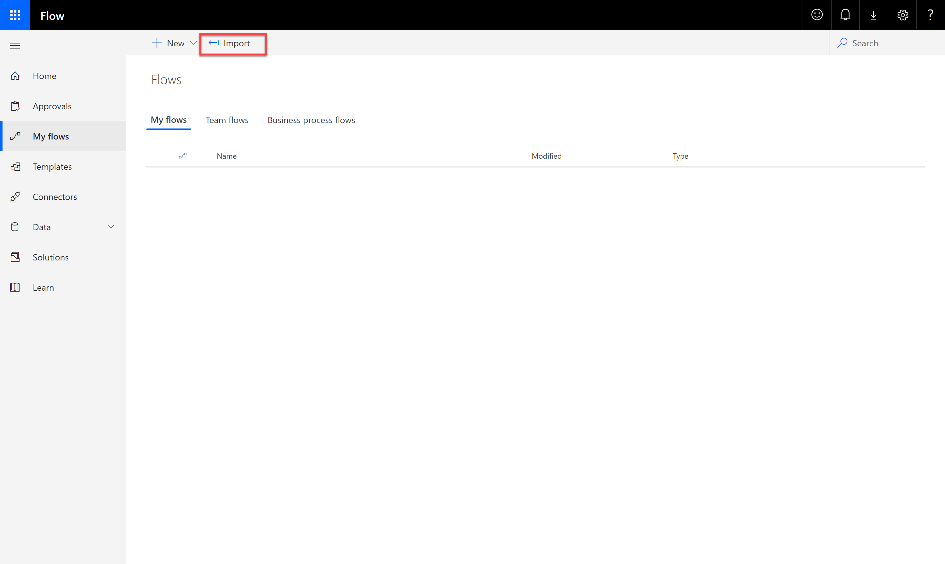

1. Upload the .zip file names ProcessFeedback_Flow.zip that has been provided for this workshop.  
     
   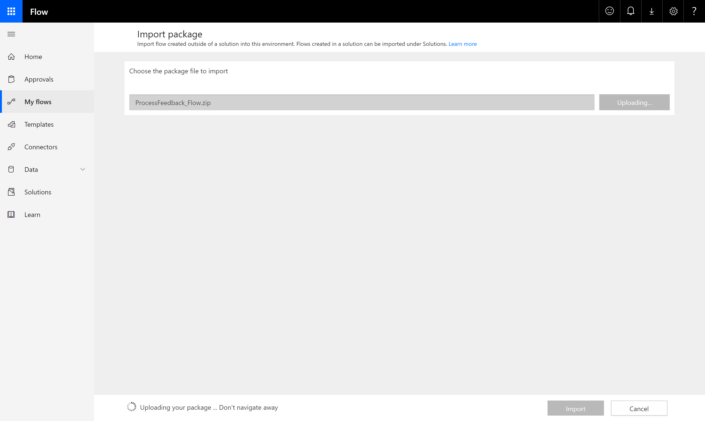
2. Once the package details are displayed, click on the tool icon next to the Common Data Service (current Environment) Connection.

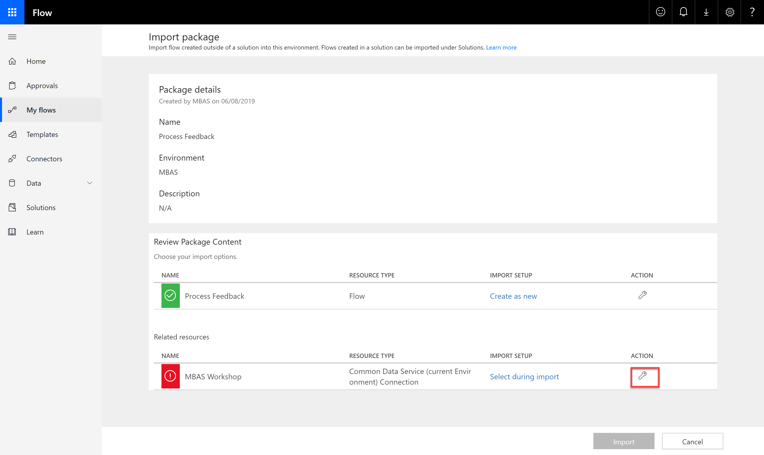

1. Click on Create New Connection.

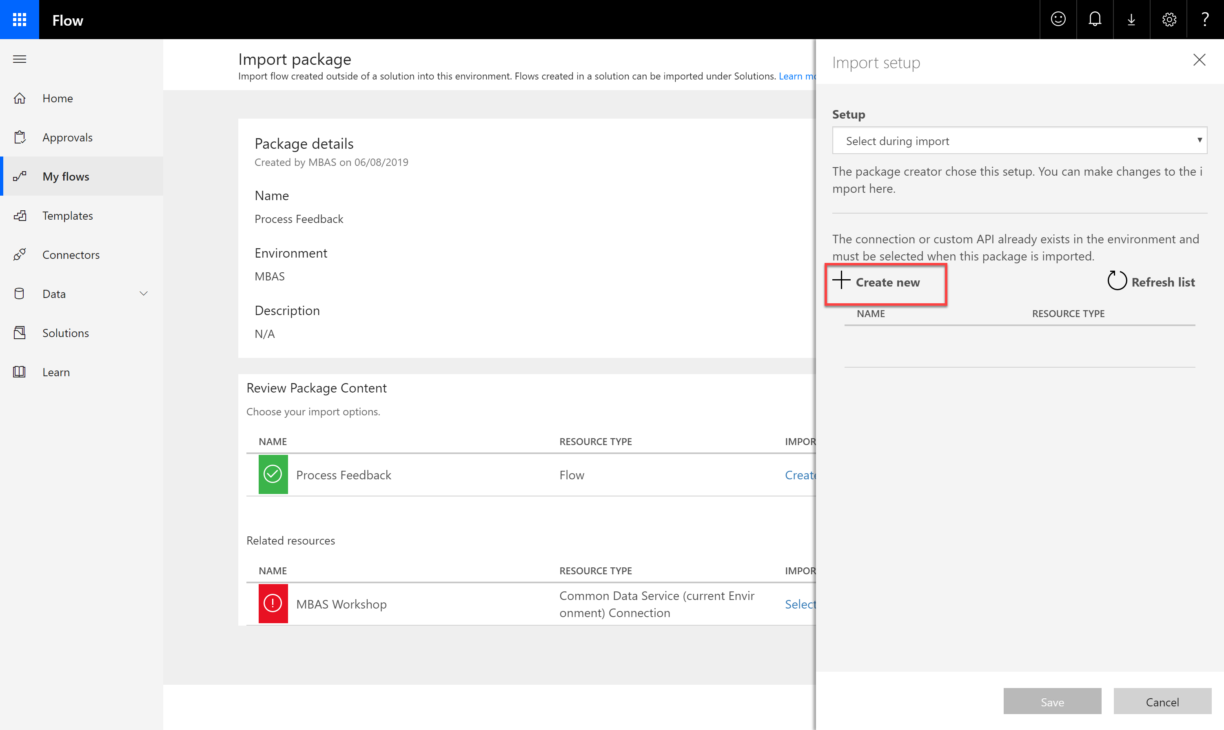

1. Once you land on the connections screen, click on Create New Connection.

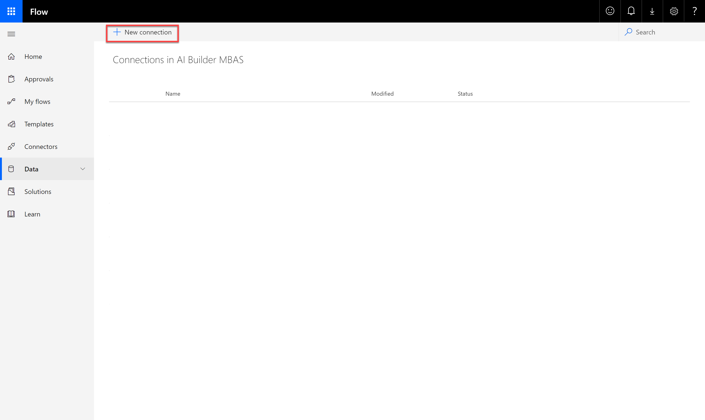

1. Select Common Data Service (current environment).

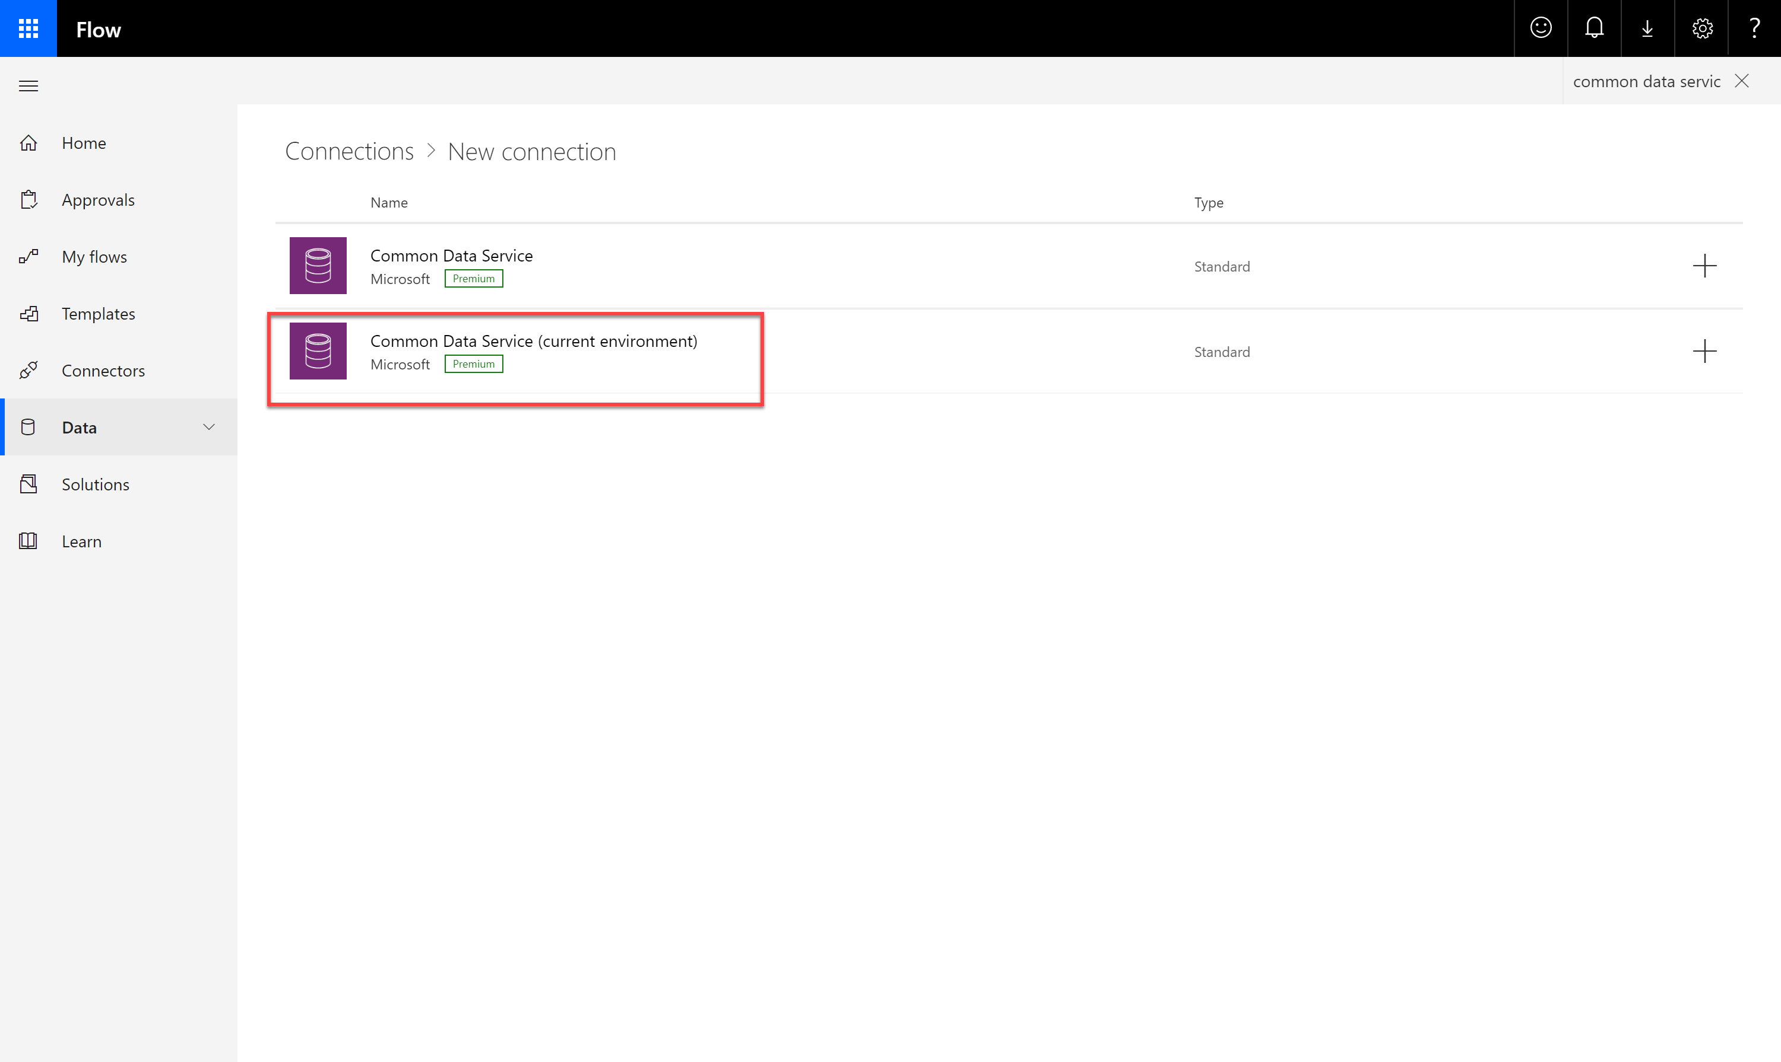

1. Create the connection

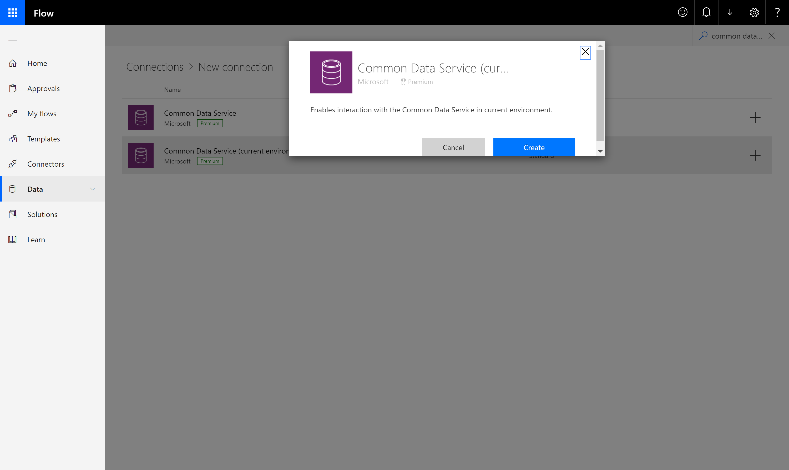

1. Once the connection has been successfully created, return to the Import Package screen. You should now see your newly created connection on the right. Click refresh if not.

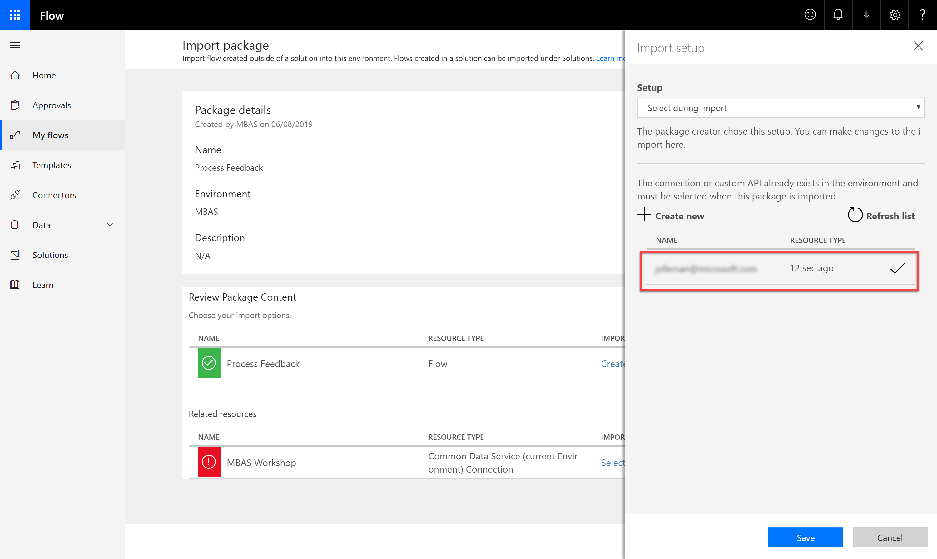

1. Once done click on Import.

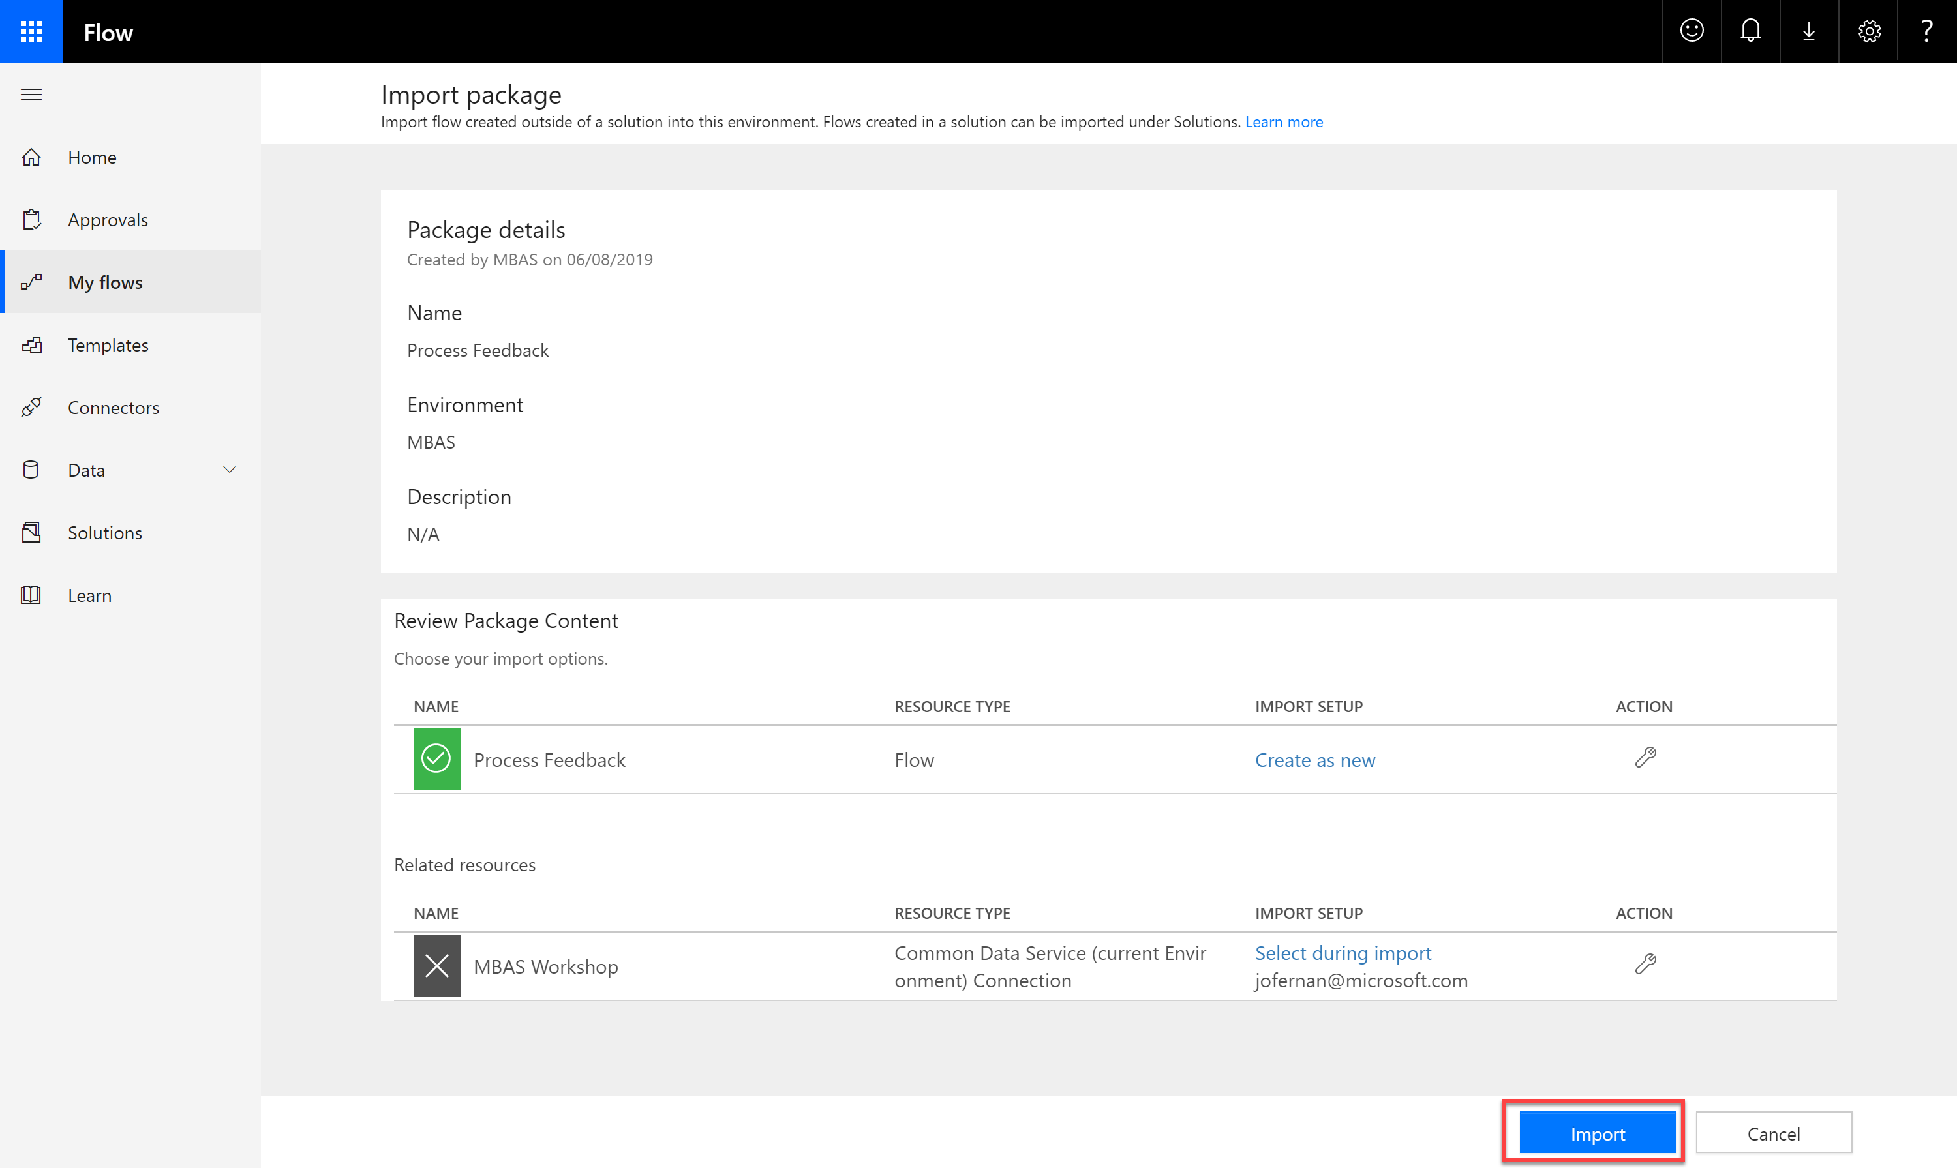

1. Once completed the import, Open the Flow.

## Task 2 – Invoke Predict and Parse the output

1. Expand the Predict action and on the Model dropdown locate and select your model you built in the previous exercise.

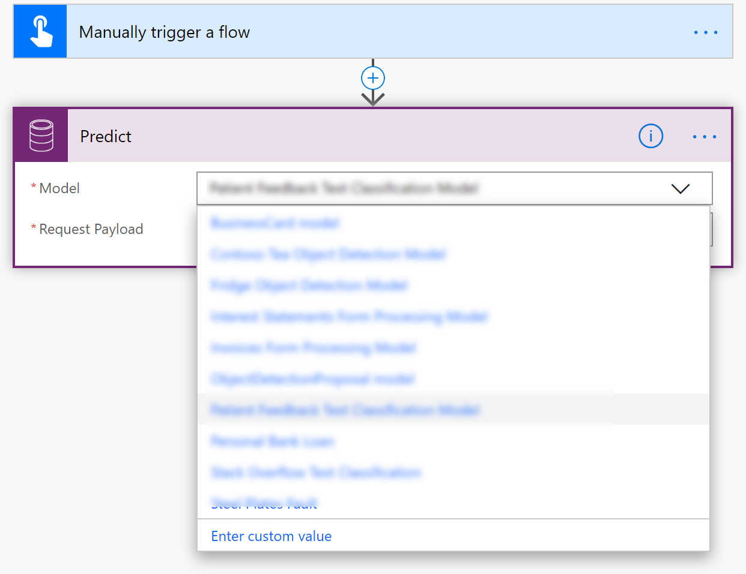

1. The Request Payload was pre-configured and should look like the following. What you are doing here is providing the input to the Predict action and connecting it to the text you will input when the flow is run.

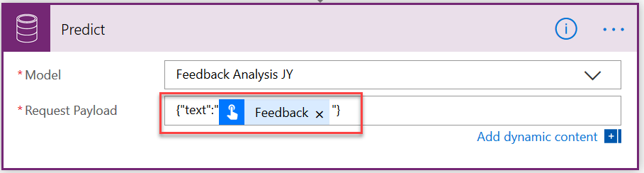

1. Next, because the Predict action can work with different types of models, the output can contain different data. So future steps can easily use the output. We are going to use a Parse JSON action that will parse the output and make it available to subsequent steps with known names.
2. Click + New Step and type Parse JSON in the search field.
3. Select the Parse JSON action.

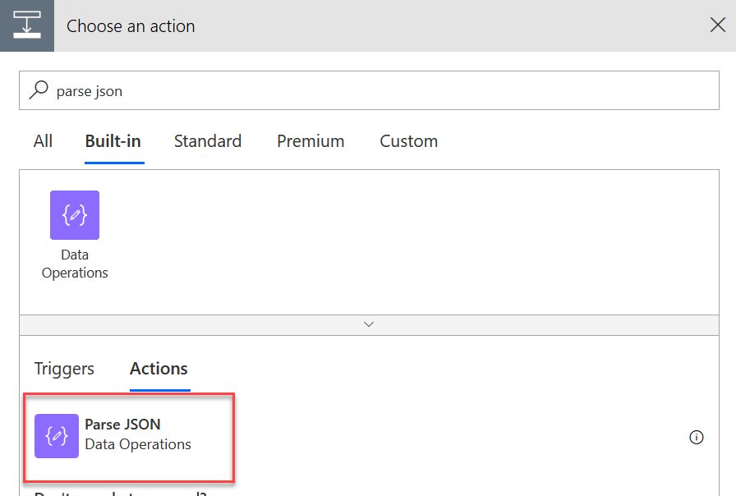

1. Click in the Content field and select Response Payload from the Dynamic content panel.

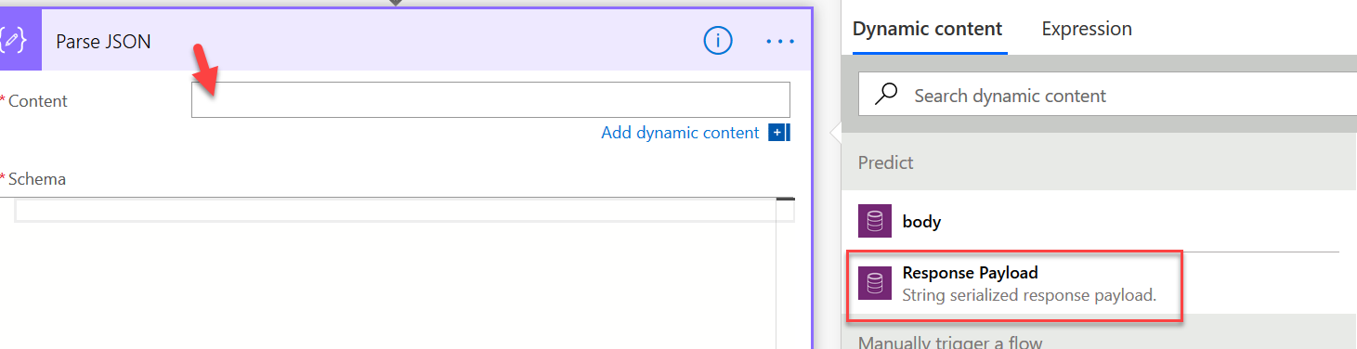

1. Next click in the Schema field and paste in the following. This is a schema that tells the parse action what to expect in the content. You will be able to find this in the docs site in the future.

{

"type": "object",

"properties": {

"predictionOutput": {

"type": "object",

"properties": {

"results": {

"type": "array",

"items": {

"type": "object",

"properties": {

"type": {

"type": "string"

},

"score": {

"type": "number"

}

},

"required": [

"type",

"score"

]

}

}

}

},

"operationStatus": {

"type": "string"

},

"error": {}

}

}

1. Let’s check to make sure things are good so far. Click Test in the upper right corner.
2. Choose I’ll perform the action and click Save & Test.
3. In the Feedback field type The facilities are wonderful.
4. Click Run Flow and then click Done.
5. Your flow should have run successfully and should look like the following. Click Edit to resume making changes.

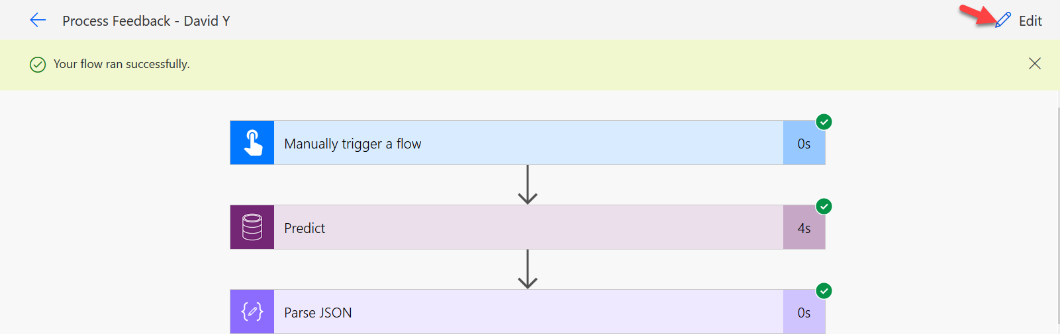

## Task 3 Process the output

In this task we are going to take the output and use it to email the different departments. The Predict might classify multiple tag matches, each returned with a type and a score. We only want to send a copy of the feedback to the departments when the score is greater than 63. To accomplish this, we will add a condition action and check the score and the type. For each one that passes the criteria and we will send an email.

1. Click + New Step and search for Condition.
2. Select the Filter array action.

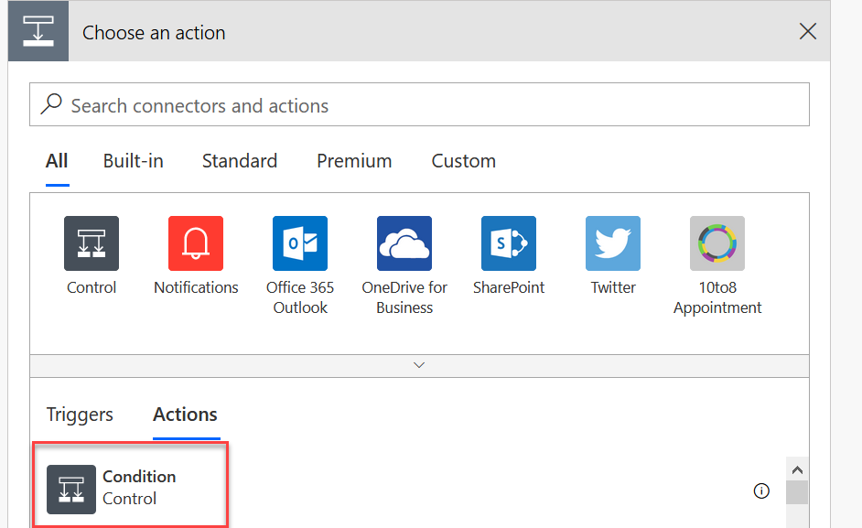

1. Click in the Choose a value field and select type from the Dynamic content panel.

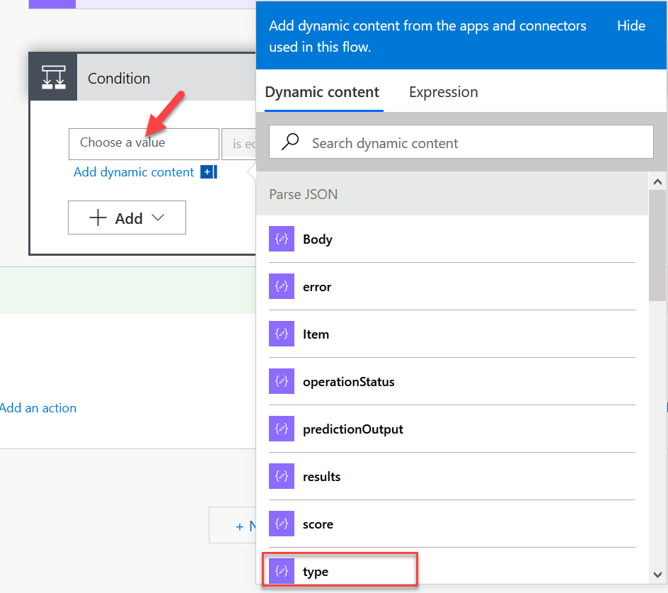

1. Because there could be multiple type and score records returned, flow will wrap your condition in an Apply for each action and it should now look like the following

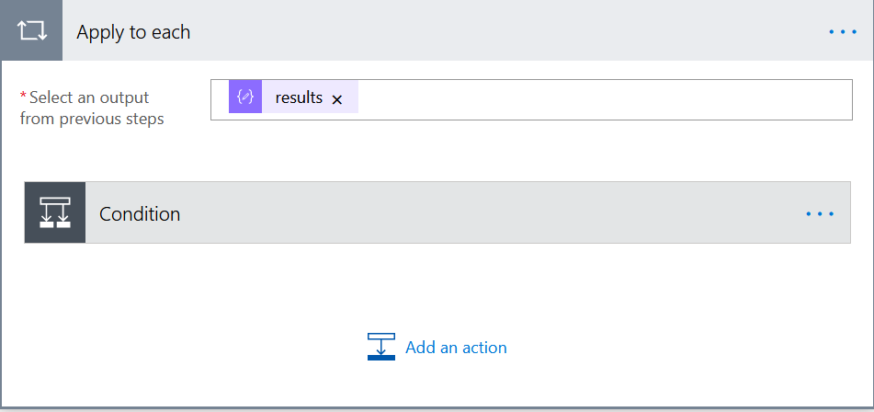

1. Click on the Condition action to expand it.
2. Click in the second Choose a value field type Staff.

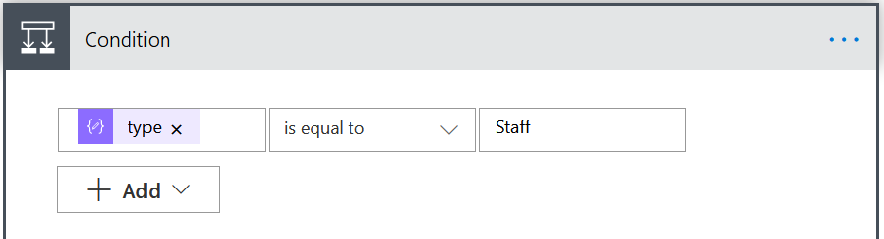

1. Click + Add and then + Add Row to add a second check in the condition for type.

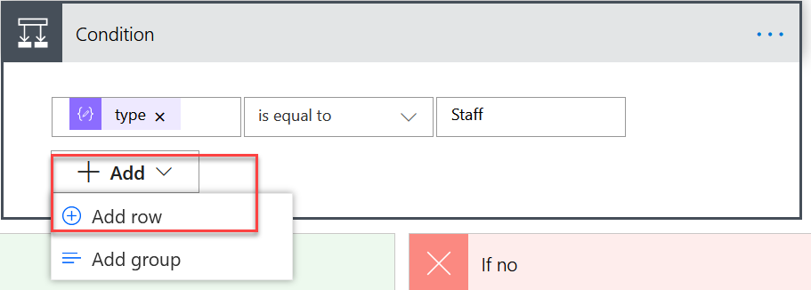

1. Click in the Choose a value field, and select score in the Dynamic content pane.

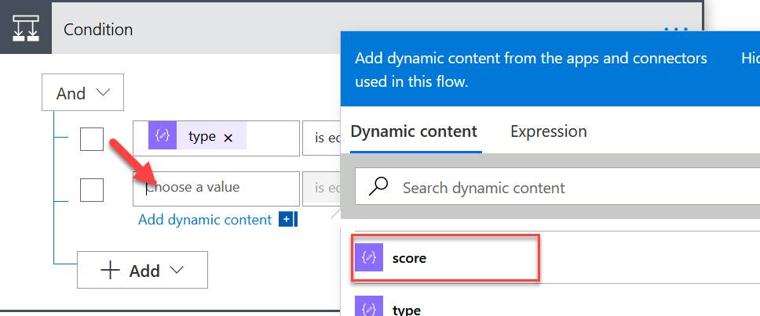

1. Change the operator to is greater than and type 0.63 in the second value field.

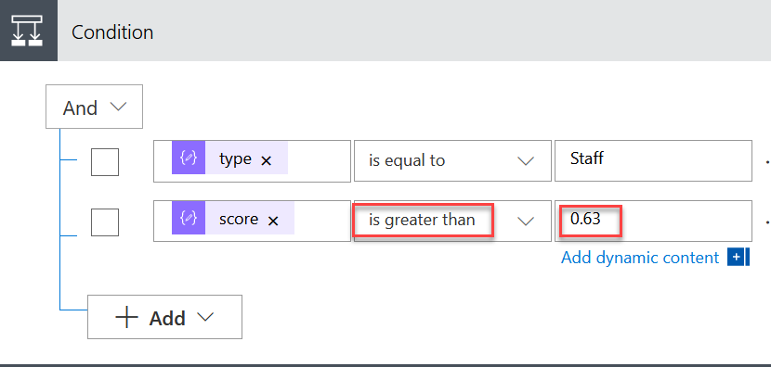

***Double check that the value is 0.63 and not .63 otherwise the flow will fail.***

1. Inside the If Yes path of the condition, click Add an action

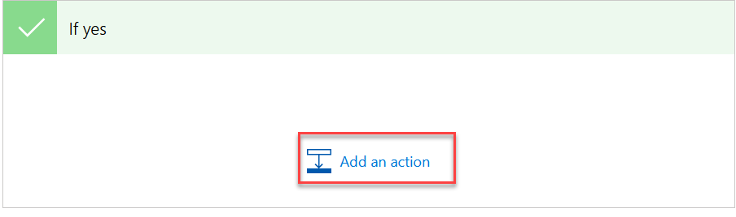

1. Search on Send an Email.
2. Select Send an **email (v2).**
3. In the To field type your lab user.
4. In the subject type Staff Feedback.
5. Click in the body and select Feedback in the Dynamic content panel.

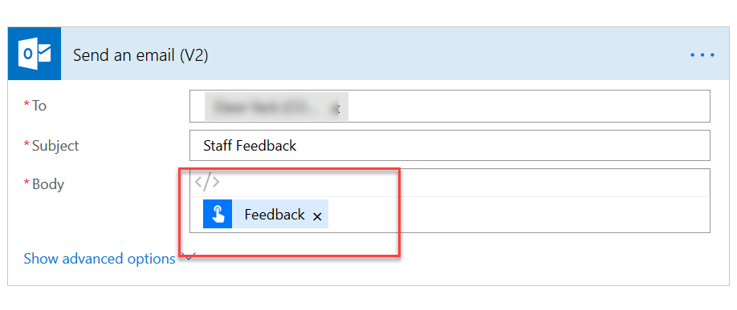

1. Click Test and then choose I’ll perform the action and then click Save and Test.
2. In the feedback paste the following:

The doctors were very professional, nurses were kind and attentive, the room was nice but the food at the cafeteria and in room is terrible

1. Click Run Flow.
2. Your flow should run successfully and should look something like the following. You should also now have an email with the feedback.

